## Photo Uploader App

[link](https://medium.com/@jgefroh/software-architecture-image-uploading-67997101a034)

Features to Implement

* Displaying the image on the front-end
* Authorizing users to download the image
* Authorizing users to upload the image
* Uploading the image to your server in a scalable way
* Validating the image data
* Processing the image, performing cropping, optimization, and other tasks
* Creating image variants, such as banners and thumbnails
* Storing the images

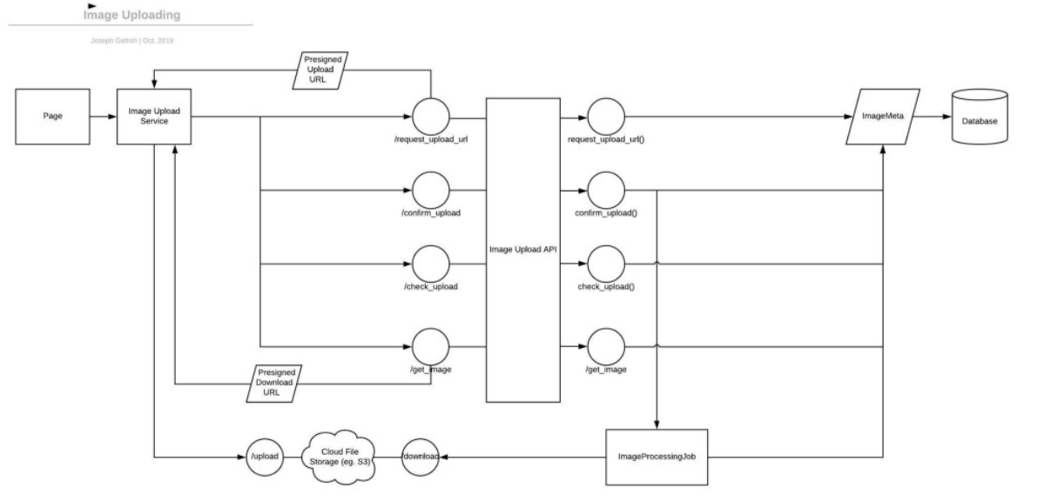

## Online Food order Architecture

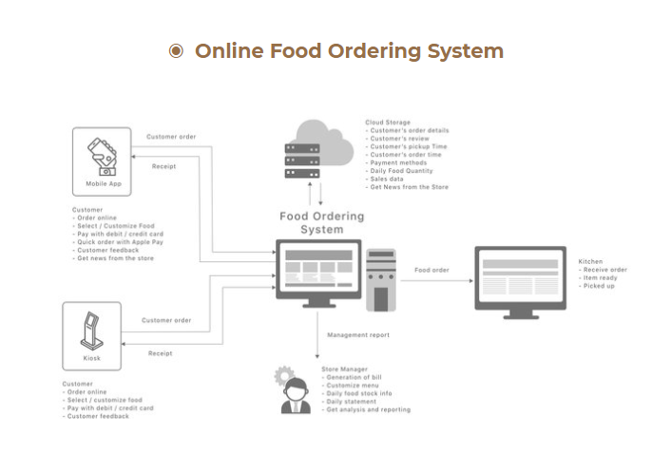

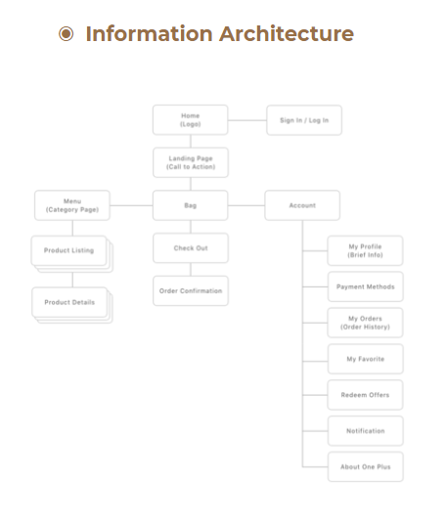

## 

## 

## 

## 

## 

## Use Case Diagram for Cab Booking service

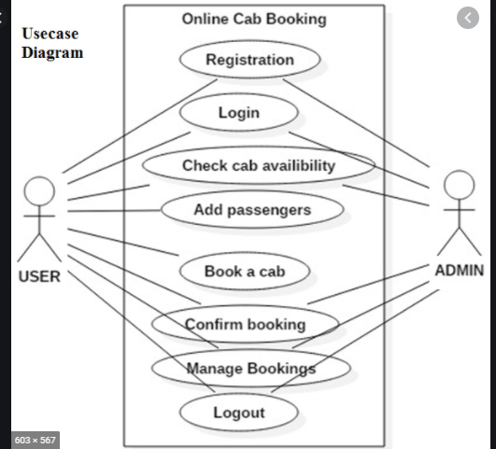

## UBER Case study [Uber Case Study](https://medium.com/edureka/microservice-architecture-5e7f056b90f1)

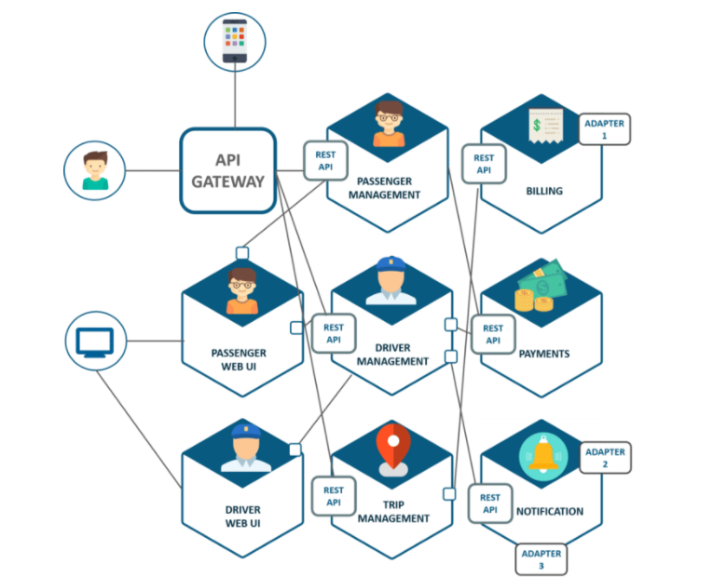

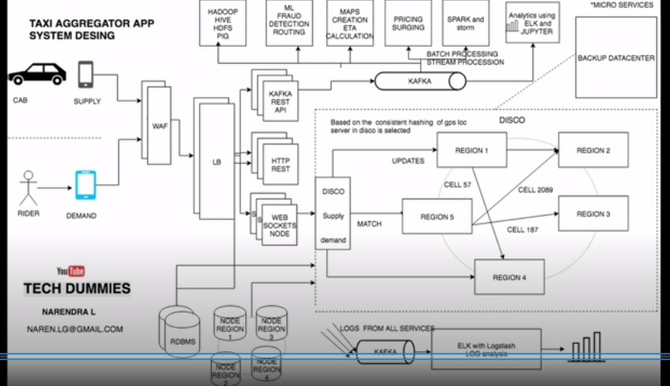

## Pros and Cons of Microservices Architecture

